**Student:** Muhammad Abdullah

**ID:** L00171275

**Marks and feedback**

|  |  |  |  |
| --- | --- | --- | --- |
| **Element** | **Available** | **Awarded** | **Comments** |
| Festival programme | 10 | 5 | The application should load predefined festival programme and display that information. The user should not have to add it to the application. App crashes on Android! |
| Detailed information on artists/bands and sponsors | 10 | 5 | I shouldn’t have to add artist information. This should be retrieve by the application for the user. Details not displayed correctly after being added. Additional information on artists required (bio, external links to examples of work, social media links?). |
| Allow users to add or remove items to/from their personal programme. | 10 | 5 | You could have implemented this via a details page with a favourites icon and a Boolean toggle in the artist information. Or you could have implemented swipe view see: <https://learn.microsoft.com/en-us/dotnet/maui/user-interface/controls/swipeview?view=net-maui-7.0> |
| Search | 10 | 3 | Not working correctly. Partial search only. Should be able to search by artist, stage, time, genre |
| Persistent storage (serialization or database) | 20 | 14 | Good use of SQL lite (although you should have a solution for mobile!) and interface and data service for each model. |
| UX | 20 | 11 | The user experience of the application could be improved in a number of regards, see general comments for details. |
| Advanced features | 20 | 12 | You have created data service interfaces and objects for each of the models which replicates a microservice architecture approach. Well done on adopting this approach. |
| **CA Total** | **100 * .8** | (55 * .8) 44 |  |
| **Video** | **20** | 11 | You should have run the application on an android emulator to give a better view of the application rendered on a mobile device. |
| **Total** | **100** | 55% |  |

**General comments**

There was no need to add events to the music festival application. This functionality would not be exposed to an end user and the assignment specification made no reference to this requirement! The only remotely related requirement was to add/remove performances in the schedule to a personal schedule. You really should have used the video to convey your understanding of the underlying code rather than demonstrate the user interface. Also, if you are recording a video, you shouldn’t include the application crashing. Fix the bug and re-record the video if necessary.

The user experience of the application could be improved in a number of regards. The main screen would benefit from some images of artists or festival goers enjoying themselves. This would be much more visually appealing than pain text. The text is cut off at both sides of the label. You need to test your application on the target platform more rigorously. The colour scheme is fine and generally applied consistently across the application. Use of resource dictionary to define application wide colours and themes is a good idea.

The application crashes when running it on android as your code the SetUpdb method was written for windows and the path to the folder for the application data differs between windows, Android and iOS! You are meant to make a mobile application primarily. You can use platform specific code (see lecture on platform features) to write code that branches appropriately based on the platform the code is running!

The festival programme should be prepopulated with acts that the user can view. Good contextual menu but no need to edit. Delete and view would be more appropriate. The acts in the schedule should be better ordered (by day/time). Nice label/frame around the text. Artist details page should contain more information. What would users find most useful? A short bio on the band, performance schedules, add to personal schedule option and samples of their work via youtube, soundcloud or spotify.

Overall there is a lot of work in this assignment and you have successfully managed to implement an application using .NET MAUI and C#. The assignment solution deviates from the requirements in the assignment specification however! I have no idea why you included functionality that wasn’t requested. Good use of MVVM design pattern and SQLite through the data services. You have created data service interfaces and objects for each of the models which replicates a microservice architecture approach. Well done on adopting this approach.

**Video presentation**

|  |  |  |
| --- | --- | --- |
| **Classification** | **Organisation (5%)** | **Knowledge and understanding of the topic (15%)** |
| 80% - 100%  Outstanding work | Excellent, well directed video presentation, logically structured. | Comprehensive depth of knowledge and clear understanding of major and complex principles and  concepts of cross platform development with .NET MAUI. |
| 70% - 79%  Excellent work | Well directed video presentation, logically structured | Comprehensive knowledge and clear understanding of major and complex principles and concepts of cross platform development with .NET MAUI. |
| 60% - 69%  Good quality | Clearly presented, logically structured. | Substantial knowledge and clear understanding of major principles and concepts of cross platform development with .NET MAUI. |
| 50% - 59%  Acceptable | Neat presentation and structure. | Evidence of knowledge and clear understanding of a range of principles and concepts of cross platform development with .NET MAUI. |
| 40% - 49% Adequate work | Weak presentation and structure. | Knowledge and understanding of key principles and  concepts limited or inconsistent of cross platform development with .NET MAUI. |
| Marginal Fail  35% - 39% | Poor presentation and structure. | Very limited knowledge and understanding of key principles and concepts of cross platform development with .NET MAUI. |
| Fail  0 – 34% | Unacceptable presentation, and structure. | Little or no evidence of knowledge and/or understanding of key principles and concepts of cross platform development with .NET MAUI. |

**Screenshots:**

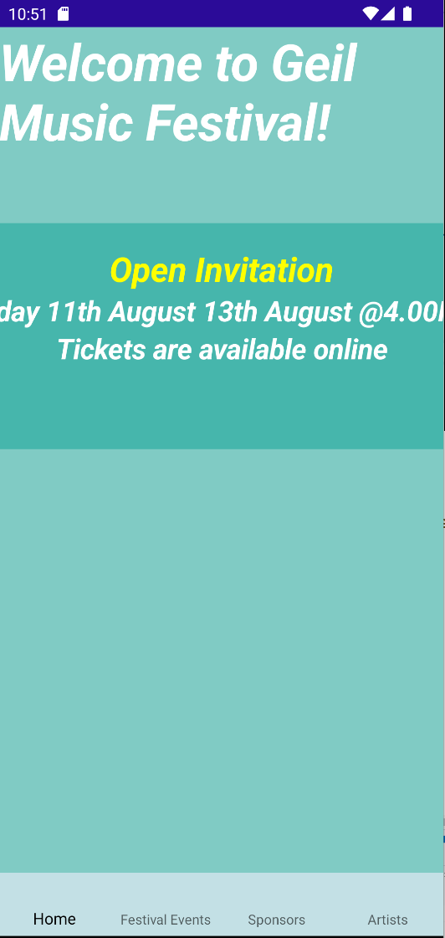 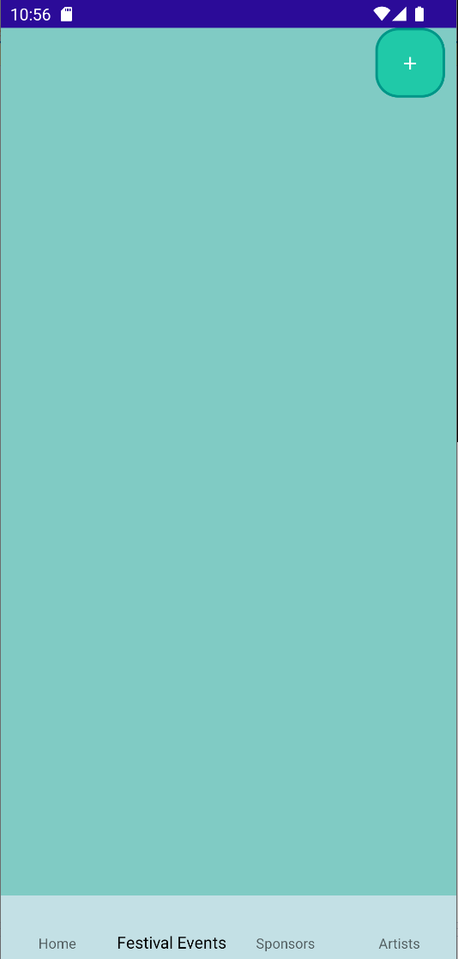 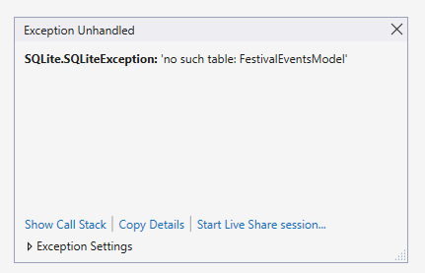

Main screen Blank festival event screen Application crashes when attempting toe view the programme

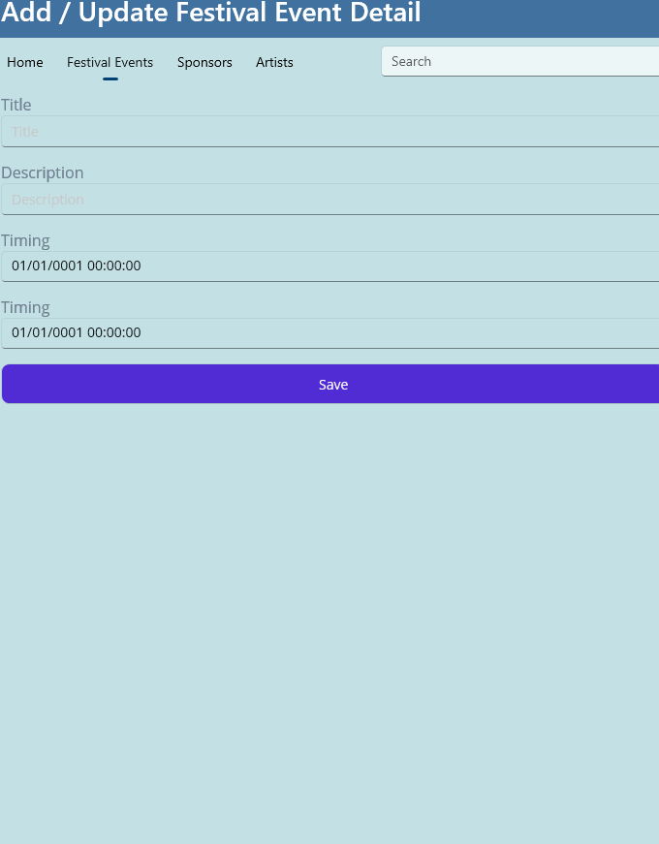 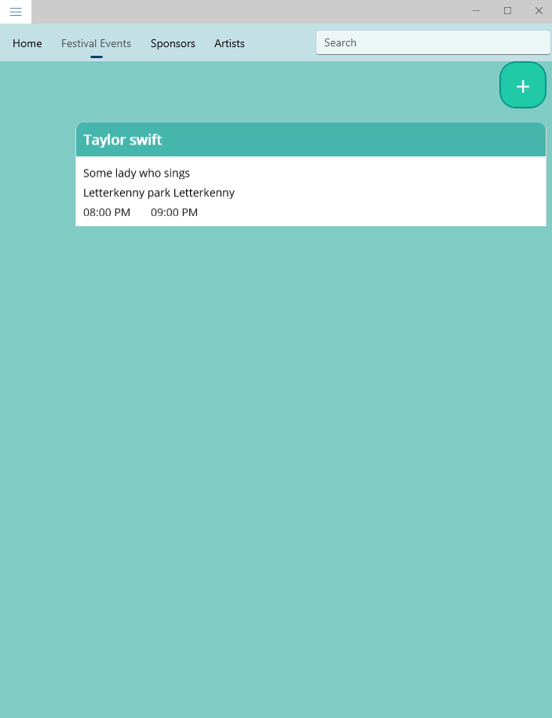 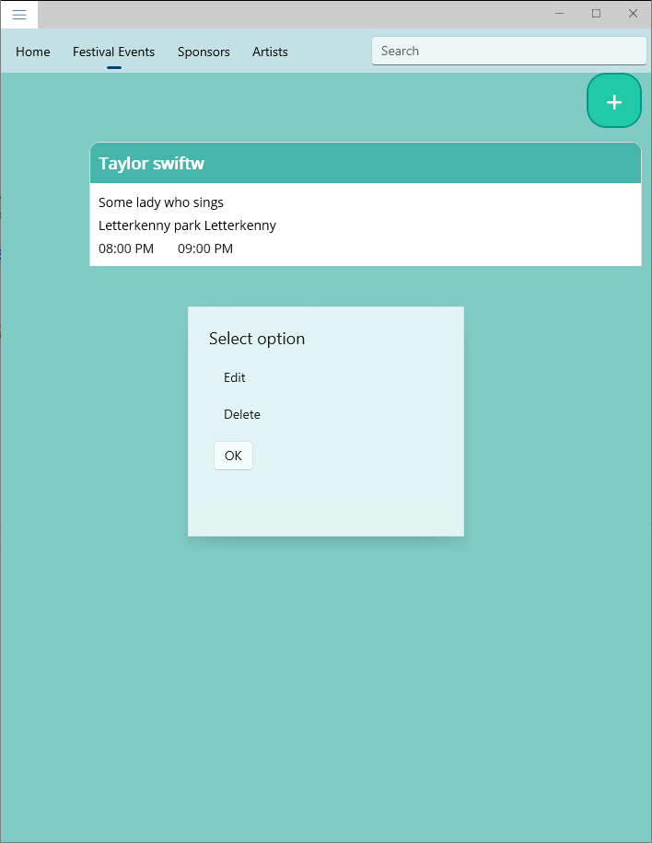

Creating a festival event on windows Details saved within the application Contextual menu to edit and delete

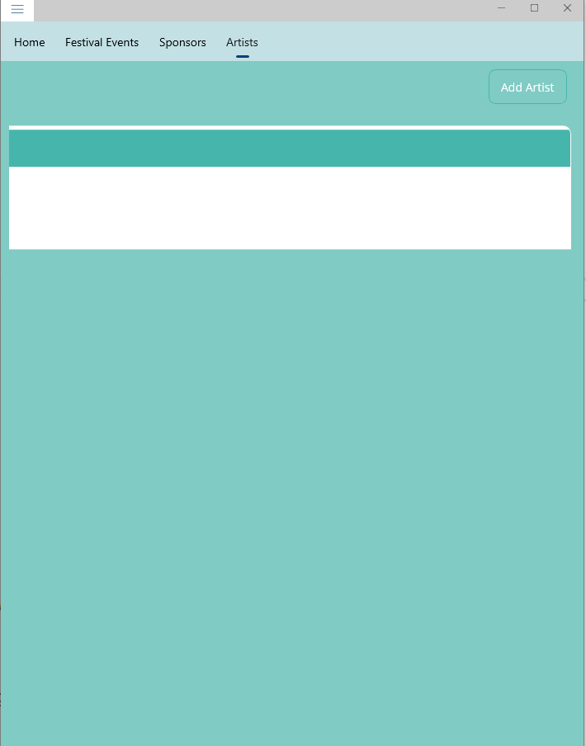

Artists details not being displayed correctly after being added